**Practical 3**

**Program:**

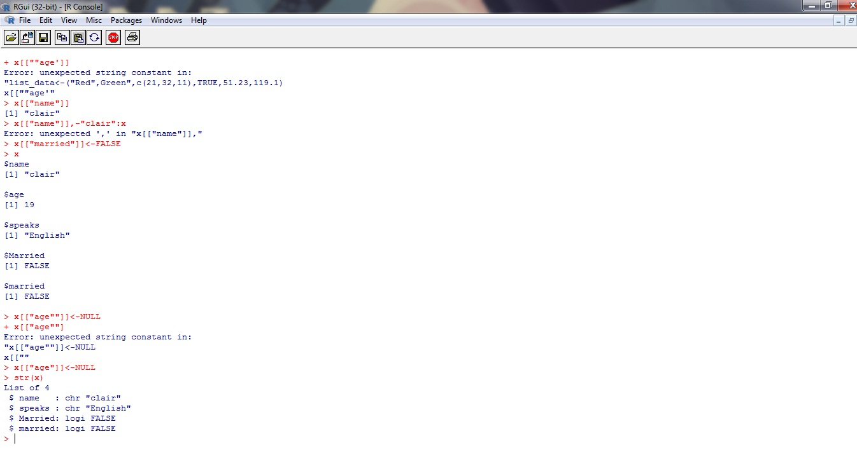

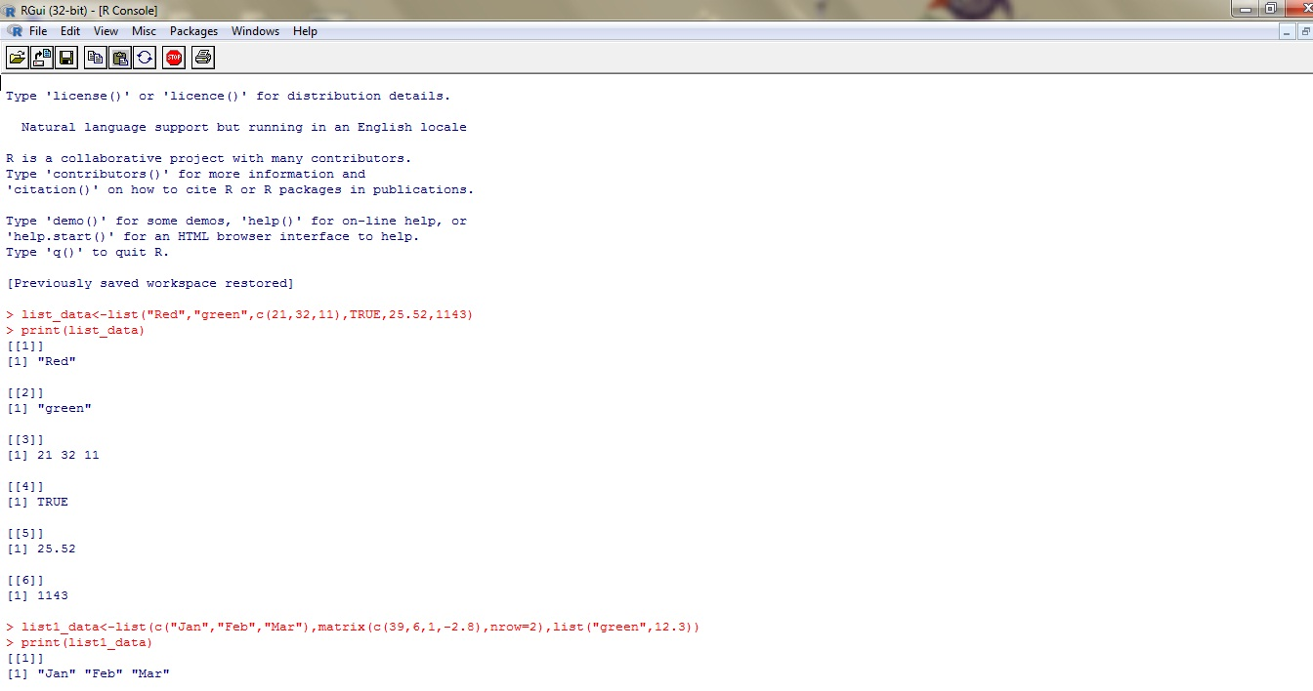

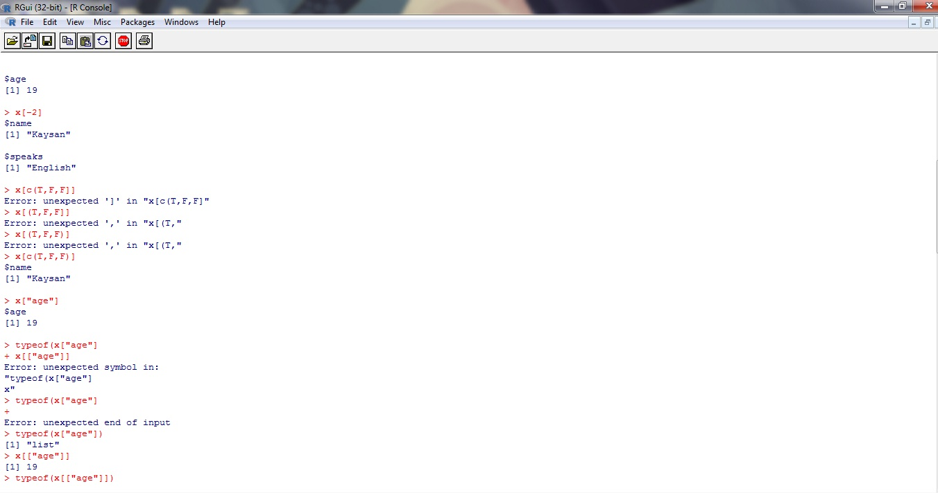

> list_data<-list("Red","green",c(21,32,11),TRUE,25.52,1143)

> print(list_data)

[[1]]

[1] "Red"

[[2]]

[1] "green"

[[3]]

[1] 21 32 11

[[4]]

[1] TRUE

[[5]]

[1] 25.52

[[6]]

[1] 1143

> list1_data<-list(c("Jan","Feb","Mar"),matrix(c(39,6,1,-2.8),nrow=2),list("green",12.3))

> print(list1_data)

[[1]]

[1] "Jan" "Feb" "Mar"

[[2]]

[,1] [,2]

[1,] 39 1.0

[2,] 6 -2.8

[[3]]

[[3]][[1]]

[1] "green"

[[3]][[2]]

[1] 12.3

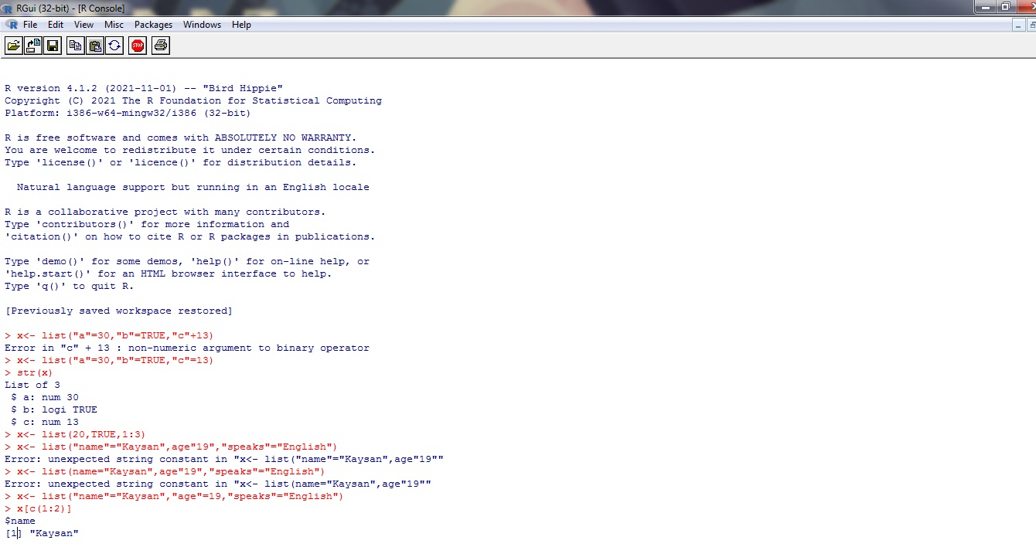

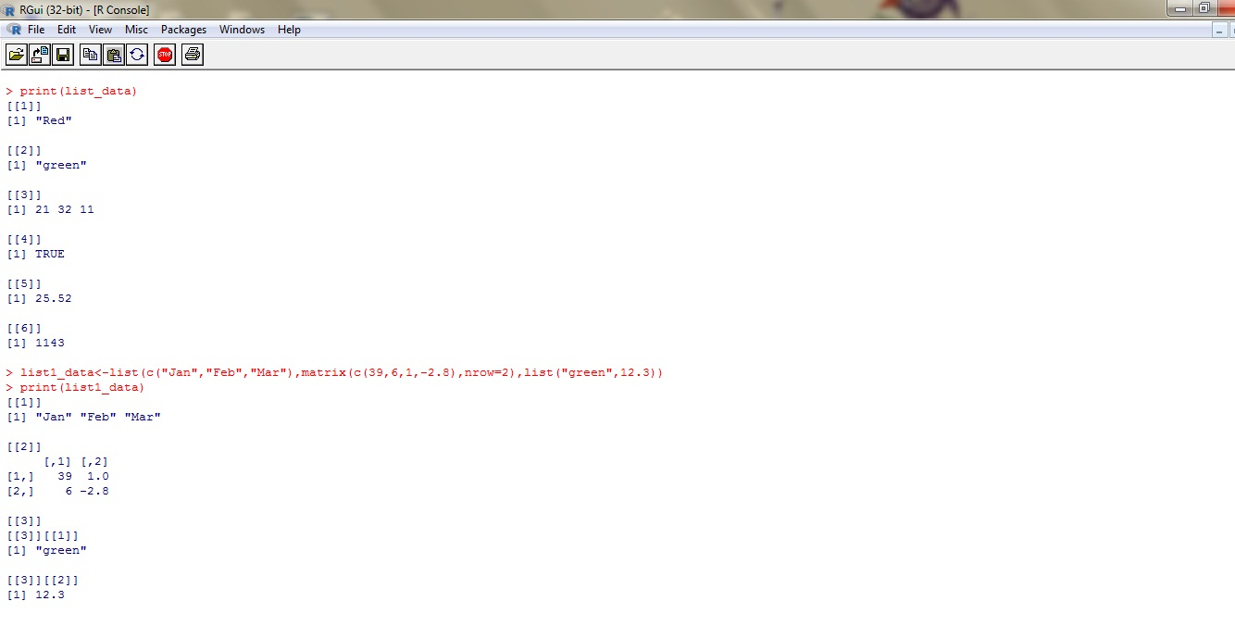

> # Give names to the elements

> names(list_data<-c("1st Quarter","a-matrix","A_linear_list")

+ [a]

+ [["ace]]

+ [["age]

Error: unexpected symbol in:

"[["ace]]

[["age"

> names(list_data)<-c("1st Quarter","a-matrix","A_linear_list")

> print(liat_data[1])

Error in print(liat_data[1]) : object 'liat_data' not found

> print(list_data[1])

$`1st Quarter`

[1] "Red"

> print(liat_data[3])

Error in print(liat_data[3]) : object 'liat_data' not found

> print(list_data[3])

$A_linear_list

[1] 21 32 11

> print(list_data $A_Matrix)

NULL

> list_data[9]<-"New element"

> print(list_data[9])

$<NA>

[1] "New element"

> list_data[9]<- NULL

> print(list_data[9])

$<NA>

NULL

> #Update

> list_data[3]<-"updated element"

> print(list_data[3])

$A_linear_list

[1] "updated element"

> #Merging lists

> list1<- list(1,2,3)

> list2<- list("Thursday","Saturday","Sunday")

> print(merge.list)

Error in print(merge.list) : object 'merge.list' not found

> merge.list<-c(list1,list2)

> print(merge.list)

[[1]]

[1] 1

[[2]]

[1] 2

[[3]]

[1] 3

[[4]]

[1] "Thursday"

[[5]]

[1] "Saturday"

[[6]]

[1] "Sunday"

> #Creating a list

> list1<-list(1:5)

> print(list1)

[[1]]

[1] 1 2 3 4 5

> list2<-list(15;16)

Error: unexpected ';' in "list2<-list(15;"

> list2<-list(15:16)

> print(list2)

[[1]]

[1] 15 16

> #Convert list to vector

> v1<- unlist(list1)

> v2<- unlist(list2)

> print(v1)

[1] 1 2 3 4 5

> print(v2)

[1] 15 16



